Build a Neural Network model for 50_startups data to predict profit

|  |
| --- |
| normalize <- function(x){  + return((x-min(x))/(max(x)-min(x)))  + }  > startup_norm<-as.data.frame(lapply(`50_Startups`[,-4],FUN=normalize))  > summary(startup_norm)  R.D.Spend Administration Marketing.Spend Profit  Min. :0.0000 Min. :0.0000 Min. :0.0000 Min. :0.0000  1st Qu.:0.2415 1st Qu.:0.3993 1st Qu.:0.2741 1st Qu.:0.4249  Median :0.4418 Median :0.5437 Median :0.4509 Median :0.5254  Mean :0.4459 Mean :0.5333 Mean :0.4473 Mean :0.5481  3rd Qu.:0.6145 3rd Qu.:0.7122 3rd Qu.:0.6348 3rd Qu.:0.7044  Max. :1.0000 Max. :1.0000 Max. :1.0000 Max. :1.0000  > train <- startup_norm[1:25,]  > test <- startup_norm[26:50,]  > library(neuralnet) # regression  > library(nnet) # classification  > startup_model <- neuralnet(Profit~R.D.Spend+Administration+Marketing.Spend,data = train)  > plot(startup_model)  > model_result <- compute(startup_model,test)  > str(model_result)  List of 2  $ neurons :List of 2  ..$ : num [1:25, 1:4] 1 1 1 1 1 1 1 1 1 1 ...  .. ..- attr(*, "dimnames")=List of 2  .. .. ..$ : chr [1:25] "26" "27" "28" "29" ...  .. .. ..$ : chr [1:4] "" "R.D.Spend" "Administration" "Marketing.Spend"  ..$ : num [1:25, 1:2] 1 1 1 1 1 1 1 1 1 1 ...  .. ..- attr(*, "dimnames")=List of 2  .. .. ..$ : chr [1:25] "26" "27" "28" "29" ...  .. .. ..$ : NULL  $ net.result: num [1:25, 1] 0.516 0.549 0.561 0.498 0.51 ...  ..- attr(*, "dimnames")=List of 2  .. ..$ : chr [1:25] "26" "27" "28" "29" ...  .. ..$ : NULL  > predicted_profit <- model_result$net.result  > cor(predicted_profit,test$Profit)  [,1]  [1,] 0.8645221  > plot(predicted_profit,test$Profit) |
|  |
| |  | | --- | |  | |

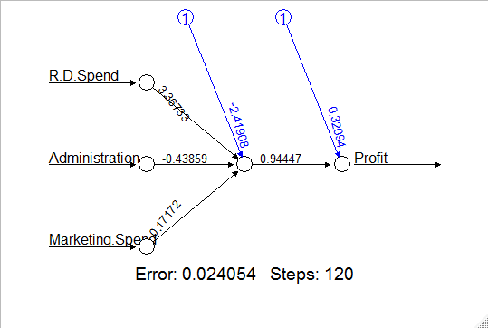

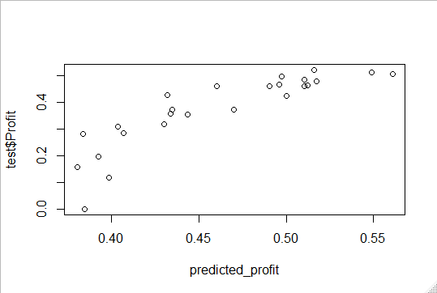

plot(predicted_profit,test$Profit)

> model_5<-neuralnet(Profit~R.D.Spend+Administration+Marketing.Spend,data= startup_norm,hidden = 5)

> plot(model_5)

> model_5_res<-compute(model_5,test)

> pred_strn_5<-model_5_res$net.result

> cor(pred_strn_5,test$Profit)

[,1]

[1,] 0.9155087

> plot(pred_strn_5,test$Profit,col="blue")

